|  |
| --- |
|  |
| Project Report |
|  |
|  |
|  |
|  |

|  |
| --- |
|  |

Contents

Introduction 1

Objectives of inventory 2

Scope of the project 5

INVENTORY manager can view all members and view all product currently in the INVENTORY. Perspective of the Product 5

Software Requirements 5

Project Requirements 6

Functional Requirements: 6

Non-Functional Requirements: 7

Characteristics of the application user: 7

INVENTORY manager can view the remaining fee of the members of the INVENTORY. Constraints for the Online INVENTORY: 8

Design of the System: 8

Primary Design of the system: 8

Secondary Design of the system: 8

Project Diagrams: 9

Database design image: 10

UML diagram: 11

References 12

Introduction   
Inventories means the stock of the product of a company and components thereof that makes up the product. It includes the raw materials, work in progress and finished goods. It is the physical stock of items a business or production organization kept in hand for the efficient running of business or its production.  
A stock of items held to meet future demand ν Inventory is a list for goods and materials, or those goods and materials themselves, held available in stock by a business.  
  
Inventories are: -  
 1. Items in stock.  
 2. Usable but idle resources. Inventory control Process of maintaining optimum needed quantity of inventories for the smooth operation of organization.

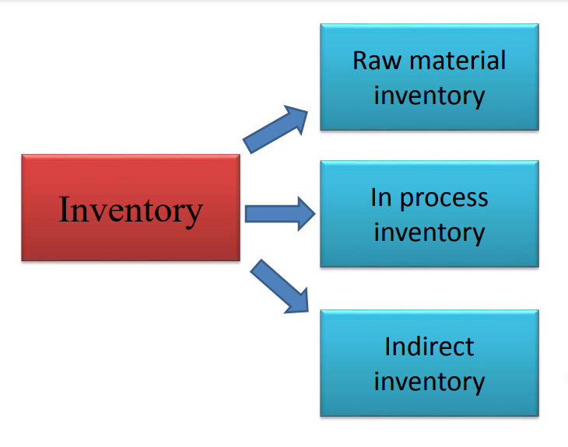

Objectives of inventory   
control the basic managerial objectives are 2 fold:  
 1. Avoid over/under investment in inventories.   
 2. To provide right quantity and quality goods at right time at proper value.  
  
  
Operating objectives:   
  
Availability of Materials: All type of material available at all time so that production may not be held up for want of supply of materials.  
  
 Minimizing the wastage: permit only uncontrollable wastage. Avoid wastage by leakage theft, embezzlement, spoilage (rust, dust, dirt)  
  
 Promotion of manufacturing efficiency: When right type of raw material is available at the right time.   
  
Better service to the customers: Maintain proper production flow to produce sufficient finished goods to meet the demand of of the customers  
  
 Control of production level: To increase or decrease the production as per the demand as well as to maintain proper buffer stock to meet any eventuality in difficult times.  
  
 Optimal level of inventories: It is done in view as per the operational requirements.it also avoids the out of stock danger.  
  
Financial objectives:  
 1. Economy in purchasing: management makes every attempt to purchase the raw materials in bulk quantity and to take advantage of favorable market condition.   
2. Optimum investment and efficient use of capital: The finance management should set up maximum and minimum levels of stocks to avoid deficiency or surplus of stock position.  
 3. Reasonable price: Management should ensure supply of raw materials at a reasonable low price without sacrificing the quality of it thereby helping the cost of production and quality of finished goods. Advantages of inventory   
 Delivery in time: as inventory stored aids smooth production, the manufacturing company can earn reputation as a reliable supply. Our finished goods can be raw materials for buyers. Reputation can get more customers  
 2. Possibility of discount on bulk purchase   
 3. Efficiently handle unforeseen circumstances  
 4. No idling of workers and machineries  
 Disadvantages of inventory  
 1. Working capital tied up: can’t utilize the amount for neither other purposes nor it yield any interest.   
 2. More space required: more inventories more is the space needed and space accounts for rent.  
 3. Increase insurance charges: Increased cost of handling and manufacturing.  
 4. Increased overhead expenses: Security personnel required to guard inventory.   
 5. Chances of damage: Pilferage, replacement, etc. more.   
 6. Increased chance of obsolesce.  
Type of inventory:  
Basic inputs that are converted into finished product through the manufacturing process.  
  
Work in progress” Goods Semi-manufactured products need some more works before they become finished goods for sale.  
  
 Finished Goods Completely manufactured products ready for sale.  
  
 Supplied Goods – Office and plant cleaning materials not directly enter production but are necessary for production process and do not involve significant investment.  
   
  
Tasks in Inventory Management  
  
Track inventory – To look after the amount of inventory i.e. stock coming into the business.  
How much to order? – To specify units of inventory to be used by organization.   
When to order? – Specify the duration of getting the inventory.

# Scope of the project

The project spans a number of sectors, from the business sector to the computer industry, where the project includes:

* Provides the facility to view the earning chart for the INVENTORY manager.
* INVENTORY manager can view the member’s chart.
* INVENTORY manager can view the membership chart.
* INVENTORY manager can view total product in the INVENTORY.
* INVENTORY manager can view total account in the INVENTORY.
* INVENTORY manager can view the total fee stats.
* INVENTORY manager can view total earning of the INVENTORY.
* INVENTORY manager can view the remaining fee of the members of the INVENTORY.
* List of members with the expired memberships can also be viewed.
* This project allows the INVENTORY owner or caretaker the options to add new member.
* INVENTORY manager can add new product.
* INVENTORY manager can view allocations of the product.

# INVENTORY manager can view all members and view all product currently in the INVENTORY. Perspective of the Product

This product provides the INVENTORY manager with the stats of the INVENTORY about each and every thing in the INVENTORY including the earning chart, members chart, membership chart, total members in the INVENTORY , total product , total fee, total earning, remaining fee and the expired memberships.

# Software Requirements

* **Front End:**
* ASP.net mvc using Visual Studio 2019
* **Back End:**
* Microsoft SQL Server 2019

# Project Requirements

The requirements of the project are divided into two types according to the software engineering principles:

1. Functional Requirements.
2. Non-functional Requirements.

## Functional Requirements:

**R.1 Login:**

* Valid credentials insertion.
* Successful login upon the correct credentials.

**R.2 Dashboard:**

* Provides the facility to view the earning chart for the INVENTORY manager.
* INVENTORY manager can view the member’s chart.
* INVENTORY manager can view the membership chart.
* INVENTORY manager can view total members in the INVENTORY.
* INVENTORY manager can view total product in the INVENTORY.
* INVENTORY manager can view the total fee stats.
* INVENTORY manager can view total earning of the INVENTORY.
* INVENTORY manager can view the remaining fee of the members of the INVENTORY.

**R.3: Add new member:**

* Details of the member must be added.
* Member details must be saved in the database.

**R.4: Add new Transaction :**

* Details of the product must be added.
* Product details must be saved in the database.

**R.5: Allocate customer:**

* Allocation of product with the member must be done.
* Allocation details must be saved in the database.

**R.6: View Allocation:**

* Allocation details must be fetched from the database.

**R.7: View all members:**

* Member list must be fetched from the database.
* Member list must be displayed when required.

**R.8: View all product:**

* product list must be fetched from the database.
* Product list must be displayed when required.

## Non-Functional Requirements:

It addresses the system aspects that are important for the functionality of the system. Some non-functional device specifications are as follows:

* The system helps the user to navigate the web interface system. The web application is used as a device interface. The system is user-friendly, and the system is easy to implement.
* When dealing with the customer input, the system should have the high degree of performance and be able to respond quickly to customer feedback.
* Errors should be treated in a satisfactory manner. As far as possible, the error rate should be minimized. A suitable error message must be sent to the customers. There should also be as much less time to recover from a mistake.
* In order to encourage consumers to use the system at the moment, the system needs to be available everywhere. When failure happens, the device should be recovered as early as possible in order to ensure that the company does not suffer badly (scaledagileframework, 2021).
* The system should be user friendly, so that someone with even less system awareness can use it

# Characteristics of the application user:

The system has only one user that is the manager of the inventory and is able to perform the following operations using the Online INVENTORY application:

* INVENTORY manager can view the member’s chart.
* INVENTORY manager can view the membership chart.
* INVENTORY manager can view total members in the INVENTORY.
* INVENTORY manager can view total product in the INVENTORY.
* INVENTORY manager can view the total fee stats.
* INVENTORY manager can view total earning of the INVENTORY.

# INVENTORY manager can view the remaining fee of the members of the INVENTORY. Constraints for the Online INVENTORY:

A member or admin must be registered in the Online INVENTORY in order to view his or her details and payments and membership histories.

# Design of the System:

In this step, a logical system is defined according to the particular requirements. In software development the design phase is the phase in which the user's needs are translated into logical modules.

* Primary Design of the system.
* Secondary Design of the system.

## Primary Design of the system:

In this step, an abstract application with major requirements is built. Blocks are formed based on the problem found in the problem identifying process. For various functions, various blocks are formed. A particular module or feature represents each block.

## Secondary Design of the system:

Each and every module of the system is detailed and designed in this phase of the designing of the software application. The major and important steps of this phase of the design are stated as follows:

* Similar blocks are built for the entire system process
* Any block comprises small, compact and functional modules.
* Database architectures are designed for particular modules
* Details of the software are defined to achieve the necessary functionality
* Designing of the system's input and output forms.
* Documents are made for the template
* Detailed device design analysis is carried out.

# Project Diagrams:

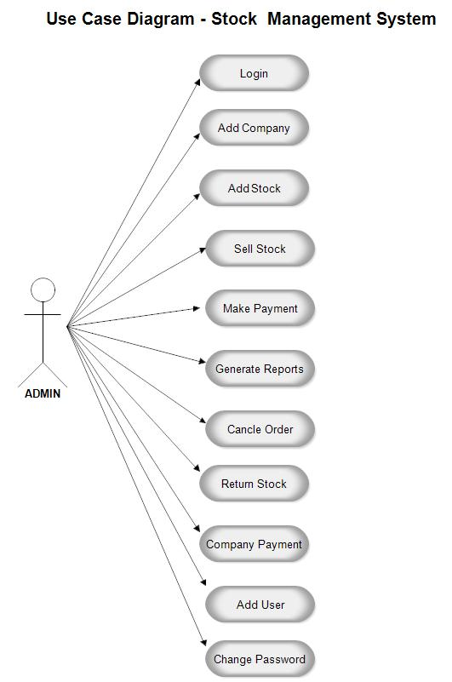

# Database design image: 2020] Inventory Management System Database Design Project | ERD

# UML diagram: UML Diagrams Point Of Sale Terminal | Programs and Notes for MCA

# 

# References

scaledagileframework. (2021). *Nonfunctional Requirements.* Retrieved from www.scaledagileframework.com: https://www.scaledagileframework.com/nonfunctional-requirements/#:~:text=Nonfunctional%20Requirements%20(NFRs)%20define%20system,system%20across%20the%20different%20backlogs.&text=They%20ensure%20the%20usability%20and%20effectiveness%20of%20the%20entire%2

visual-paradigm. (2021). *What is Data Flow Diagram?* Retrieved from www.visual-paradigm.com: https://www.visual-paradigm.com/guide/data-flow-diagram/what-is-data-flow-diagram/